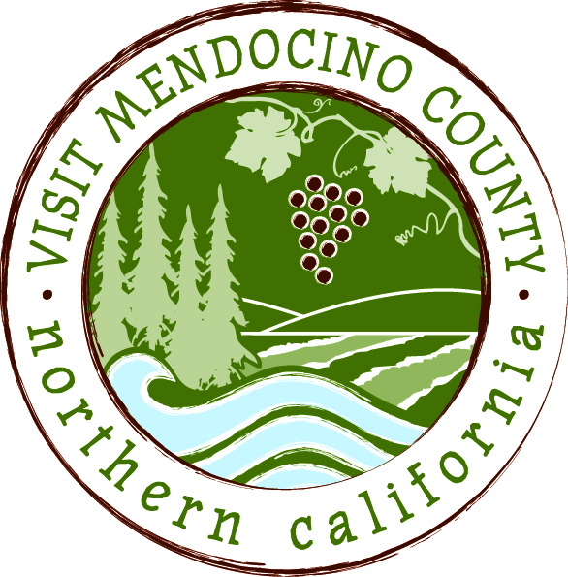

BOARD OF DIRECTOR’S AGENDA

Date: April 23, 2015 Time: 1:00 PM
Dial-in Number: | 1-605-475-5950
Participant Access Code: | 694806
Place: Little River Inn, Little River, CA

- Call To Order
- Public Comment & Introduction
- Message of the Chair
- Closed session
A. Personnel Matters – Bylaws Section 4.3:
Discussion of Board of Supervisors ad hoc committee recommendations for modification of termination and severance provisions of employment agreement.
Public Employee Title: President and Chief Executive Officer
B. Personnel Matters - Bylaws Section 4.3:
Approval of proposed Agreement for Modification of Agreement for Employment.
Public Employee Title: President and Chief Executive Officer
- Announcement out of closed session

- Approval of Minutes – April 13th and April 14th – ACTION: Approve Minutes
- Old Business
  - Resolution for Glenna Blake – ACTION: Approve Resolution
  - 2015/2016 Marketing Plan and Budget – ACTION: Approve Plan & Budget
  - Travel and Expense Policy – ACTION: Approve Policies
VIII. New Business
- Authorize Organizational Name Change – ACTION: Approve Name Change
- MCLA/VMC Contract Extension – REPORT. Board Comments Encouraged
- Transformational process – possible ad-hoc appointment – OVERVIEW: Possible appointment

Schedule Next Meeting May 12, 2015 – Inland TBD

VII. Adjourn

