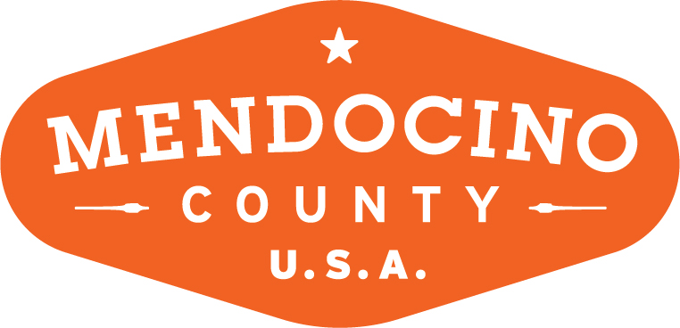

MENDOCINO COUNTY TOURISM COMMISSION, INC.
MARKETING COMMITTEE MINUTES

DATE: Wednesday August 1, 2018 TIME: 11:00AM
LOCATION: Ukiah Valley Conference Center, 200 School St., Ukiah CA 95482

*Please note: In accordance with the Brown Act, call-in locations must be listed on the agenda. If anyone from the public is calling in during the meeting, it must be done from or at the locations above.
- CALL TO ORDER
11:10AM
- ROLL CALL
Cally Dym, Susie Plocher, Bernadette Byrne, Wendy Roberts
VMC: Travis Scott, Alison de Grassi; Vanlee Waters, Richard Strom (phone); Guests: Chip Sheean and Russell Quinan (TSF)
- PUBLIC COMMENT –Pursuant to the Brown Act, the Committee cannot discuss issues or take action on any requests during the comment period
Cally Dym raises the idea that the Festival and Marketing Committees meet on the same day with the Festival Committee meeting first. Some of the committee members overlap and combining efforts will lead to a better understanding of what each committee is doing and how to achieve consistent goals. The next Festival/Marketing meeting will be in September.
- APPROVE MINUTES: July 10, 2018
BB moves to approve; Wendy seconds; unanimous
- ACTION ITEM: COMMITTEE TO VOTE ON NOMINATION OF KATRINA KESSEN (ECOTERRA) TO COMMITTEE
Following a short discussion among members, the committee voted unanimously to invite Katrina Kessen to join.
- MUSHROOM FESTIVAL :
  - CONFIRMATION OF NAME
Update on name: the new name for the fall festival is “Feast Mendocino.” The committee discussed using this branding as the over-arching brand for the festivals going forward.
  - BROCHURE REFRESH
The festival brochure will be updated to reflect the new festival branding. For 2018, the design will remain more or less unchanged with the ads appearing in the back of the brochure. Imagery will be larger and provide more appeal to the target market. Paper stock will most likely be matte. VMC anticipates a change to layout for the upcoming January festival.
  - ANCHOR EVENT UPDATE
Travis described the activities for the November 10 event at EcoTerra that will include food, olive oil, wine, mixology, mushroom workshops and more.
- THEORYSF:
  - BRAND LAUNCH CAMPAIGN OVERVIEW AND RESULTS
The brand launched both online and offline. TSF presents an analytics review that shows (YOY 2018 v. 2017) an 800%+ increase in top line traffic. New visitors are up 879% over same period. Quantcast (an analytics system) is installed on the website to deeply track psycho- and demographics. Metrics to date reveal that current users are interested in culinary and news/politics. Therefore, Feast Mendocino is a crucial event for the brand and the culinary overlay is crucial to event success. Visitors are particularly interested in travel and accommodations. The main channel currently is referral traffic vs. organic search, which is down as is direct search. The top pages visited are fun things to do, MendoMoments, bucket list, etc. Business listings have received 14,389 views since June 1. TSF presented the draft stakeholder report that goes to each stakeholder on the site with an email address. Wendy Roberts commented that it’s excellent to see work and results that tie directly to the Strategic Plan.
  - WHERE DO WE GO FROM HERE?
Russell discussed positioning from this point forward. He presented the committee with the offline marketing campaign assets currently showing around the SF Bay Area. The campaign objectives were to introduce Mendocino, drive top line awareness, and drive traffic to the website. Mission accomplished! BB asked for engagement figures for social media videos, which will be supplied by Brendan McGuigan. Advertising and PR work together… it’s a continual job to message the marketplace. Russell demonstrates the advertising funnel from advertising, through PR, to events, to website, to purchase.
Moving forward: VMC has an ad campaign, and money. There are three directions: 1/ Advertising; 2/ Promotions; 3/ Press-worthy stunts – that blur the lines between advertising and storytelling: story-doing.
1/ Advertising:
    - move into the Sacramento market
    - Geo-programmatic targeted Pandora radio (25-54 yrs. Mendocino playlist); can do an ad and targeted playlist
    - Online interactive videos
    - BART total domination! Pillars, tunnel wraps, trains
    - Geo-fencing; proximity based ad serving
    - Paid search – smart; delivers ROI
    - Retargeting – 6x on conversion; call to action
2/ Promotions:
- The Great Mendocino Key Hunt – press-worthy; need to build awareness levels (on the back burner)
- SF VMC Pop-up Experience – installation experience in a public space
3/ Press-worthy Stunts
- Taste of Mendocino -?
- Mendocino County coloring book
- Mendocino song writing contest
- Happy Land board game and app
- Virtual reality: Experience Natural Inner Peace
- Cooking off the grid web show: the way to Mendocino is through the stomach!

Alison will send the plan ideas to the committee to get their thoughts and the direction to take.

[Katrina Kessen joins the committee.] Cally welcomes Katrina to the committee.

NEXT MEETING DATE
Wednesday September 5, 2018 at 11AM

AGENDA ITEM
Distribution of event funds to Visits, Chambers, wine associations.
ADJOURN
Wendy moves to adjourn: 12:46 PM

