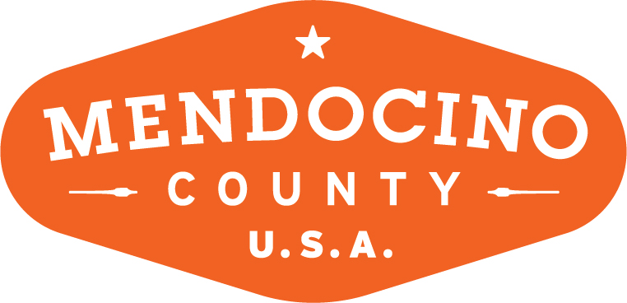

MENDOCINO COUNTY TOURISM COMMISSION, INC.
MARKETING COMMITTEE AGENDA

DATE: Wednesday June 6, 2018 TIME: 11:00AM
LOCATION: Ukiah Valley Conference Center, 200 School St., Ukiah CA 95482

CALL-IN: Visit Mendocino County, 345 N. Franklin St., Fort Bragg CA 95437
101 Gregory Lane, Willits CA 95490
3766 Feliz Creek Road, Hopland CA 95449

Dial-in Number: (712) 770-4700
Participant Access Code: 713704

*Please note: In accordance with the Brown Act, call-in locations must be listed on the agenda. If anyone from the public is calling in during the meeting, it must be done from or at the locations above.
- CALL TO ORDER
- ROLL CALL
- PUBLIC COMMENT –Pursuant to the Brown Act, the Committee cannot discuss issues or take action on any requests during the comment period
- APPROVE MINUTES: April 4, 2018 and May 2, 2018
- THEORYSF:
  - WEBSITE LAUNCH
  - WEBSITE UPDATES
  - BRAND LAUNCH CAMPAIGN
- MARKETING PLAN FOR 2018/18 FY
- MUSHROOM FESTIVAL – RENAMING/REFOCUS UPDATE

NEXT MEETING DATE

ADJOURN

