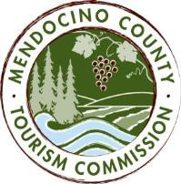

MENDOCINO COUNTY TOURISM COMMISSION, INC. MARKETING COMMITTEE AGENDA

DATE: Wednesday December 6, 2017 TIME: 11:00AM
LOCATION: Visit Mendocino County, 345 N. Franklin St, Fort Bragg, CA 95437

CALL-IN: Visit Mendocino County, 390 W. Standley St, Ukiah CA 95482
3766 Feliz Creek Road, Hopland CA 95449
101 Gregory Lane, Willits CA 95490
Please join my meeting from your computer, tablet or smartphone.
https://global.gotomeeting.com/join/260141205
You can also dial in using your phone: 1 (786) 535-3211; Access Code: 260-141-205
*Please note: In accordance with the Brown Act, call-in locations must be listed on the agenda. If anyone from the public is calling in during the meeting, it must be done from or at the locations above.
- CALL TO ORDER
- ROLL CALL
- PUBLIC COMMENT –Pursuant to the Brown Act, the Committee cannot discuss issues or take action on any requests during the comment period
- APPROVE MINUTES: November 8, 2017
- THEORYSF:
  - WEBSITE PROGRESS UPDATE
  - MUSHROOM, WINE & BEER FESTIVAL MARKETING PROMOTION RESULTS
  - CRAB, WINE & BEER FESTIVAL MARKETING CAMPAIGN
- DATA DASHBOARD

NEXT MEETING DATE

ADJOURN

