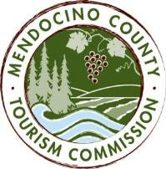

MENDOCINO COUNTY TOURISM COMMISSION, INC. MARKETING COMMITTEE AGENDA

DATE: Wednesday September 13, 2017 TIME: 11:00AM
LOCATION: Visit Mendocino County, 390 W. Standley St, Ukiah CA 95482
Visit Mendocino County, 345 N. Franklin St, Fort Bragg, CA 95437
101 Gregory Lane, Willits CA 95490
3766 Feliz Creek Road, Hopland CA 95449
4275 Maple Ave. Freeland, WA. 98249

CALL-IN: Dial-in Number: United States (712) 770-4700
Access Code: 713704

*Please note: In accordance with the Brown Act, call-in locations must be listed on the agenda. If anyone from the public is calling in during the meeting, it must be done from or at the locations above.
- CALL TO ORDER
- ROLL CALL
- PUBLIC COMMENT –Pursuant to the Brown Act, the Committee cannot discuss issues or take action on any requests during the comment period
- APPROVE MINUTES: AUGUST 16, 2017
- THEORYSF
WEBSITE MEETING UPDATE
- MARKETING PROGRAMS UPDATE: FAMILY TRAVEL WITH COLLEEN KELLY; BAY AREA LIFE
- MARKETING FOR FESTIVALS

NEXT MEETING DATE

ADJOURN

