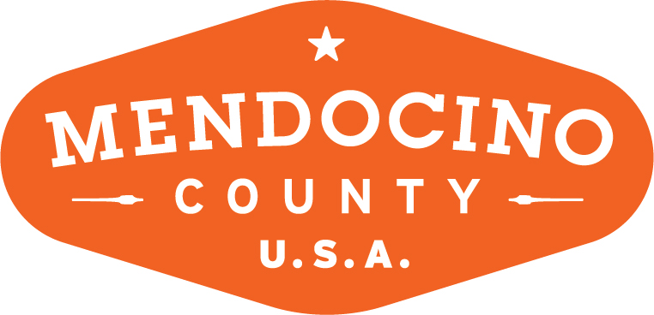

MENDOCINO COUNTY TOURISM COMMISSION, INC.
MARKETING COMMITTEE AGENDA

DATE: Wednesday September 5, 2018 TIME: 11:00AM
LOCATION: 390 West Standley St, Ukiah CA 95482

CALL-IN: Visit Mendocino County, 345 N. Franklin St., Fort Bragg CA 95437
101 Gregory Lane, Willits CA 95490

Please join my meeting from your computer, tablet or smartphone.
https://global.gotomeeting.com/join/470479965
You can also dial in using your phone.
United States: +1 (669) 224-3412
Access Code: 470-479-965

*Please note: In accordance with the Brown Act, call-in locations must be listed on the agenda. If anyone from the public is calling in during the meeting, it must be done from or at the locations above.
- CALL TO ORDER
- ROLL CALL
- PUBLIC COMMENT –Pursuant to the Brown Act, the Committee cannot discuss issues or take action on any requests during the comment period
- APPROVE MINUTES: August 1, 2018

- MARKETING COMMITTEE MEMBER ADDITION
- Alyssum Weir/Arts Council of Mendocino County

- FEAST MENDOCINO
- Rebrand & Logo Presentation
- Crab Fest Rebrand Discussion
- Feast Mendo Anchor Event

- FRINGE FESTIVAL
- How to proceed

- MARKETING PROPOSALS
- Roberta Gonsalez: Where’s Roberta?
- Tom Ward: Visit California Visitor Guide
- Dogtrekker
- THEORYSF
- Marketing Ideas From TSF – How To Move Forward
- Aggregate Stakeholder Report
- Analytics From Quantcast

- VACATION RENTALS
- Protocol about listing in event brochures

NEXT MEETING DATE

ADJOURN

