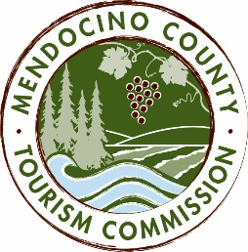

MENDOCINO COUNTY TOURISM COMMISSION, INC.
BOARD OF DIRECTORS AGENDA DATE: Thursday, May 3, 2018 10:30AM
PLACE: 444 N Main Street Fort Bragg, CA
CALL-IN LOCATIONS: none
*Please note: To abide by the Brown Act, call-in locations must be listed on the agenda. If anyone from the public is calling in during the meeting, it must be done at the posted locations above.
I. CALL TO ORDER
II. ROLL CALL
III. CHAIR’S COMMENTS
IV. PUBLIC COMMENT ON NON-AGENDA ITEMS
Brown Act Requirements: Pursuant to the Brown Act, the Board cannot discuss issues or take action on any requests during the comment period.
V. CONSENT AGENDA ITEMS
The Consent Agenda is considered routine and non-controversial and will be acted upon by the MCTC Board at one time without discussion. Any MCTC Board member may request that any item be removed from the Consent Agenda for individual consideration.
- Minutes from the 4/10/18 meeting
- MCTC Financials from 3/18
VI. Updates and Board Check in
VII CLOSED SESSION – to interview Executive Director Candidates
a. Treasurer Report
VII. FUTURE AGENDA ITEMS
VIII. NEXT MEETING
VIII. ADJOURN

