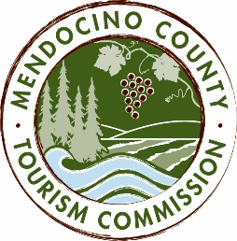

MENDOCINO COUNTY TOURISM COMMISSION, INC.
BOARD OF DIRECTORS AGENDA DATE: Tuesday, April 10, 2018 TIME: 1:00 PM
PLACE: 860 Bush Street, Ukiah CA 95482 and 120 West Fir Street, Fort Bragg, CA 95437
CALL-IN LOCATIONS: none
*Please note: To abide by the Brown Act, call-in locations must be listed on the agenda. If anyone from the public is calling in during the meeting, it must be done at the posted locations above.
I. CALL TO ORDER
II. ROLL CALL
III. CHAIR’S COMMENTS
IV. PUBLIC COMMENT ON NON-AGENDA ITEMS
Brown Act Requirements: Pursuant to the Brown Act, the Board cannot discuss issues or take action on any requests during the comment period.
V. CONSENT AGENDA ITEMS
The Consent Agenda is considered routine and non-controversial and will be acted upon by the MCTC Board at one time without discussion. Any MCTC Board member may request that any item be removed from the Consent Agenda for individual consideration.
- Minutes from the 4/20/18 meeting
- MCTC Financials from 12/17, 1/18 and 2/18.
VI. Review Annual BID Report
VII. CLOSED SESSION – to discuss Executive Director Search Update
VIII. EXECUTIVE DIRECTOR REPORT
a. Updates and 2018-19 budget update
IX. MARKETING COMMITTEE UPDATE
- Marketing Committee Chair Report
- Committee recommendation to approve additional funding for brand campaign launch
- 2018/19 Marketing Plan Draft Outline
X. ORGANIZATIONAL DEVELOPMENT COMMITTEE UPDATE
a. Committee Chair Report
XI. FINANCE COMMITTEE UPDATE
a. Treasurer Report
XII. PERSONNEL COMMITTEE UPDATE
a. Personnel Committee Chair Report
XIII. FESTIVAL COMMITTEE UPDATE
a. Festival Committee Chair Report
XIV. VISITOR SERVICES COMMITTEE UPDATE
a. Visitor Services Chair Report
XV. CANNABIS TASK FORCE UPDATE
a. Cannabis Task Force Chair Report
XVI. FUTURE AGENDA ITEMS
XVII. NEXT MEETING
XVIII. ADJOURN

